**Veterinary Science CDE Exam Questions Updated 3/30/18**

**Multiple Choice**

*Identify the choice that best completes the statement or answers the question.*

1. The term for lying on the side is
2. Cranial c. dorsal
3. ventral d. lateral recumbency
4. The term for toward the nose
5. medial c. rostral
6. distal d. proximal
7. The term *caudal* means
8. toward the head c. toward the stomach
9. toward the nose d. toward the tail
10. A sheep is called a
11. bovine c. caprine
12. porcine d. ovine
13. The term *anorexia* means
14. tired or inactive c. difficulty urinating
15. not eating d. vomiting
16. The suffix *–stomy* means
17. to make an incision c. to suture to
18. to create a new opening d. to remove
19. The term *cysto-* refers to the
20. urinary bladder c. urinalysis
21. urine d. uterus
22. Which description demonstrated direct supervision?
23. The supervisor only needs to be physically on the premises.
24. The supervisor needs to be on the premises and near enough to be of assistance.
25. The supervisor doesn’t need to be on the premises, just familiar enough with the animal to have left instructions for its care.
26. The supervisor needs to be in the same room.
27. What is the definition of “ethics”?
28. Laws passed by the government
29. Any behavior that is acceptable to you and your friends
30. Your religious beliefs
31. Rules and principles that govern proper conduct
32. Which of the following statements are true regarding confidentiality of medical records and cases?
33. Medical records and cases are ethically considered confidential
34. It is ok for information to be shared with anyone associated with the hospital
35. It is ok to share medical information with your own family members
36. Veterinary medical records and case information are not confidential, only human medical records are confidential.
37. Which of the following is NOT a breach of contract between a veterinarian and a client?
38. A client refuses to pay for services that were approved in a consent form.
39. A boarding dog escapes from the hospital premises.
40. A veterinarian guarantees a cure and the patient dies.
41. All of the above are breaches in contract.
42. Which federal agency is responsible for overseeing the manufacture and distribution of drugs used in animals?
43. Food and Drug Administration (FDA)
44. Animal Welfare Administration (AWA)
45. Drug Enforcement Agency (DEA)
46. Occupational Safety and Health Administration (OSHA)
47. The jugular vein is located
48. On the inside of the front leg c. on either side of the neck
49. Inside the thigh on the rear leg d. in the tail
50. The gestation length for a dog is
51. 30 c. 72
52. 63 d. 96
53. Which of the following is a bacterial disease?
54. Leptospirosis c. ringworm
55. Coccidiosis d. giardiasis
56. Which of the following is a viral disease?
57. Coccidiosis c. rabies
58. Tetanus d. rocky mountain spotted fever
59. A parasite that lives on hair is called
60. Flea c. mite
61. Tick d. lice
62. Cats have an average of ______________muscles in the body
63. 100 c. 300
64. 200 d. 400
65. _________can build up in the cat’s stomach due to excessive grooming
66. Bacteria c. antibodies
67. Hairballs d. weight
68. Cats go through a polyestrus cycle every _____days.
69. 5-7 c. 14-21
70. 10-14 d. 15-16
71. The total number of eggs in a nest at one time is called a:
72. Brood c. group
73. Flock d. clutch
74. What is used to determine the gender of a bird?
75. Feather sample c. DNA test
76. Blood sample d. all of the above
77. “Wet tail” causes the following in hamsters:
78. Weight loss c. nasal discharge
79. Diarrhea d. all of the above
80. Which of the following is NOT a ruminant?
81. Sheep c. elk
82. Bison d. ostrich
83. The term for a cow or dairy animal in labor is called:
84. Freemartin c. springing
85. Freshening d. heifer
86. What is the gestation length of a cow?
87. 180 days c. 195 days
88. 283 days d. 205 days
89. Which of the following diseases is a reproductive disease that may cause sterility and abortion in cattle?
90. Leptospirosis c. brucellosis
91. Bovine viral diarrhea d. displaced abomasum
92. Which of the following metabolic conditions causes low blood sugar?
93. Ketosis c. grass tetany
94. Bloat d. mastitis
95. Which of the following diseases is tested with a Coggins test?
96. Equine herpes virus c. Equine Infectious Anemia
97. Equine encephalomyelitis d. tetanus
98. What is the gestation length of a horse?
99. 365 days c. 340 days
100. 283 days d. 300 days
101. What age should a horse have all of its adult teeth in place?
102. 5 years c. 6 years
103. 2 years d. 4 years
104. Which of the following diseases is caused by Clostridium?
105. Rabies c. Influenza
106. Swamp fever d. Tetanus
107. Which of the following is NOT a part of the horse?
108. Fetlock c. poll
109. Shank d. pastern
110. What areas of the teeth may need routine floating?
111. Cups c. wolf teeth
112. Molars d. points
113. A common procedure that is used for the purpose of identification is
114. Tail docking c. snaring
115. Ear notching d. castration
116. A reproductive disease in swine that is highly contagious and has no cure is:
117. Brucellosis c. dermatitis
118. Leptospirosis d. pseudo rabies
119. What is the gestation length of sheep?
120. 148-150 days c. 135-138 days
121. 140-142 days d. 114-116 days
122. Which type of digestive system do goats have?
123. Monogastric c. non-ruminant
124. Ruminant d. avian
125. What is the gestation length of goats?
126. 100-135 days c. 148-151 days
127. 168-171 days d. 90-100 days
128. What is the incubation time of chickens?
129. 11 days c. 18 days
130. 21 days d. 15 days
131. What disease causes respiratory distress that may make a bird twist its neck?
132. Marek’s disease c. Newcastle disease
133. Infectious bronchitis d. Avian influenza
134. The study of the functions of the human body is called
135. Anatomy c. pathology
136. Physiology d. histology
137. The type of tissue that lines internal organ structures and serves as a protective layer is called
138. Connective c. muscular
139. Nervous d. epithelial
140. What type of joint rotates around a fixed point?
141. Ball and socket joint c. hinge joint
142. Fibrous joint d. pivot joint
143. Which of the following is part of the appendicular skeleton?
144. Skull c. femur
145. Mandible d. ribs
146. Which of the following is the name of the second cervical vertebra?
147. Axis c. atlas
148. Cervix d. coccyx
149. Which of the following fractures is characterized by a break in a bone that stays in place?
150. Compound c. comminuted
151. Subluxation d. simple
152. The elbow is an example of what type of joint?
153. Fibrous c. ball & socket
154. Pivot d. hinge
155. Hip dysplasia is common in which dog breed
156. German Shepherd c. beagle
157. Poodle d. pug
158. Intervertebral disc disease is common in which dog breed?
159. Corgi c. bichon
160. Spaniels d. Dalmatian
161. Which of the following animals is NOT a ruminant?
162. Pig c. goat
163. Bison d. cow
164. Herbivores would eat which of the following
165. Corn c. beef
166. Chicken d. pork
167. Wavelike motion of the digestive tract.
168. Papillae c. peristalsis
169. Mucosa d. fundus
170. Substance created by the liver.
171. bile c. glucose

b. mucosa d. trypsin

1. A condition resulting from fluid loss in the body is
2. digestion c. dehydration
3. peristalsis d. diabetes
4. A swollen and painful abdomen is a sign of
5. bloat c. overeating
6. constipation d. dehydration
7. The thin inner layer of heart muscle is called
8. myocardium c. epicardium
9. endocardium d. pericardium
10. A condition characterized by a lack of oxygen and blood reaching the tissues is
11. shock c. cardiac arrest
12. arrhythmia d. myocardial infarction
13. Inflammation of the lungs is a characteristic of
14. pneumonia c. bordetella
15. asthma d. heaves
16. A tear in the chest muscle allowing muscle to protrude through is called
17. pleural friction rub c. diaphragmatic hernia
18. heaves d. roaring
19. A respiratory infection caused by transport of livestock is called
20. bordetella c. asthma
21. shipping fever d. heaves
22. Which of the following is a building block of protein that forms in chains?
23. Fatty acids c. amino acids
24. Lipids d. enzymes
25. Which of the following is an example of a mineral?
26. B12 c. D
27. Sunlight d. iron
28. Which of the following organs produces bile?
29. Liver c. gallbladder
30. Kidney d. pancreas
31. Which of the following diets is used for an animal that is showing or hunting?
32. Maintenance diet c. growth diet
33. Reproduction diet d. work diet
34. Which of the following is a type of roundworm?
35. Trichuris vulpine c. ancylostoma caninum
36. Toxocara cati d. dirofilaria immitis
37. Which of the following parasites can cause a skin condition in humans called *cutaneous larval*

*migrans?*

1. Roundworm c. hookworm
2. Whip worm d. heartworm
3. A parasite that is flat and segmented, living in the small and large intestine is called
4. Strongyles c. giardia
5. Coccidian d. tapeworm
6. A parasite known to cause Lyme disease is
7. Tick c. mite
8. Flea d. fly
9. Which animal is at the greatest risk of developing West Nile Virus from the bite of a mosquito?
10. Cat c. goat
11. Horse d. dog
12. Which of the following is the most common source of coccidian?

a. water contamination c. bird droppings

b. food contamination d. rabbit droppings

1. Which of the following adult parasites is visible to the naked eye?
2. Roundworm c. hookworm
3. Whipworm d. coccidian
4. Which of the following insects spread heartworm disease?
5. Ticks c. mosquitos
6. Fleas d. flies
7. Which of the following types of behaviors is used to teach a young horse to lift its feet by

touching and handling the feet shortly after birth?

1. Modeling c. instinctive
2. Imprinting d. conditioning
3. Which of the following is a term for when an animal eats its own waste materials?
4. Coccidian c. pheromone
5. Maternal d. coprophagia
6. What type of aggression is displayed when an animal protects its owner?
7. Dominance aggression c. fear aggression
8. Territorial aggression d. redirected aggression
9. Which of the following factors should be considered when handling animals?
10. Temperature c. teamwork
11. Stress d. all of the above

e. None of the above.

1. Which of the following restraint equipment should not be used on cats?
2. Rabies pole c. anesthesia chamber
3. Muzzle d. squeeze cage
4. Which of the following is not an example of a veterinary safety device?
   1. Scavenger hose for anesthesia c. sterile surgery gloves
   2. Medical waste bag d. all of the above
5. Which of the following is not a class of veterinary hazards?
6. Biological hazard c. chemical hazard
7. Sharps hazard d. physical hazard
8. Which of the following agents is used to treat cancer?
9. Zoonosis c. chemotherapy
10. Bacteria d. all of the above
11. Which of the following items is available to determine hazardous ingredients and treatment

protocols for products?

1. OSHA binder c. MSDS binder
2. Right-to-know station d. none of the above
3. Which of the following is not an example of an aseptic practice?
4. Wearing exam gloves
5. Treating patients in isolation before treating surgical patients
6. Wearing a gown in the isolation ward
7. Washing hand after removing gloves
8. Which of the following is not a class of sanitation?
9. Aseptic technique c. sterilization
10. Disinfecting d. cleaning
11. Which of the following agents is used to disinfect?
12. Alcohol c. chlorhexidine
13. Iodine d. all of the above
14. Which of the following is the typical time a mercury thermometer needs to be in the rectum until

reading?

1. 1 minute c. 60 seconds
2. 30 seconds d. both A and C
3. Which of the following is a term for hair loss?
4. Alopecia c. anastomosis
5. Anorexia d. atrophy
6. Which of the following is the definition of arrhythmia?
7. Difficulty breathing c. abnormal heart beat
8. Swishing sound within the heart d. sound of cellophane within the heart
9. Which of the following is also the heart rate?
10. Temperature c. respiration
11. Pulse d. weight
12. Which of the following is NOT a cause of stress?
13. Change in diet c. infectious disease
14. Change in environment d. all of the above cause stress
15. Which of the following is the definition of hyperplasia?
16. Increased amounts of tissue c. lack of tissue
17. Decreased amounts of tissue d. abnormal tissue
18. Which of the following is a term for a vaccine?
19. Biological c. supplemental
20. Pharmaceutical d. nosocomial
21. Which of the following is a purpose for bandaging?
22. Protection c. immobilization
23. Prevention of movement d. all of the above
24. Which of the following size syringes should be used to administer a 1 ml amount of substance?
25. 10 ml syringe c. 12 ml syringe
26. 3 ml syringe d. 6 ml syringe
27. Which of the following is the reason for tapping the end of the syringe after filling it?
28. To remove air bubbles c. to mix the syringe contents
29. To read the syringe level d. all of the above
30. Which of the following is the reason for aspirating the syringe prior to injection?
31. To remove air bubbles c. to make certain the syringe is not in a blood vessel
32. to not produce pain d. all of the above
33. Which of the following is a site for an IM injection?
34. Quadricep muscles c. pectoral muscles
35. Hamstring muscles d. all of the above
36. Which of the following animals may get ear mites?
37. Dogs c. cats
38. Rabbits d. all of the above
39. Which of the following defines the term efficacy?
40. The amount of a drug c. the trade name of a drug
41. The strength and life of a drug d. the dosage of a drug
42. Which of the following is NOT a route of giving medications?
43. By mouth c. ophthalmic
44. Aural d. dram
45. Which of the following is NOT a sign of pain?
46. Vocal c. eating and drinking well
47. Restless d. chewing at incision
48. Which of the following is NOT a statement referring to surgical preparation of the patient?
49. The surgical margin should extend an inch for the incision location
50. The surgical scrub should be done in a clockwise circular motion
51. The surgical scrub should be done working from the outside inward
52. The surgical area should be clipped with #40 blades
53. Which of the following agencies usually regulate exotic species?
    1. Department of Wildlife c. Department of Treasury
    2. Department of Agriculture d. Department of State
54. What is the correct genus for Goats
55. Ovine c. Bovine
56. Caprine d. Porcine
57. What is the correct genus for Cattle
    1. Avian c. Bovine
    2. Caprine d. Ovine
58. Ovine is the correct genus for what animal
    1. Goat c. Sheep
    2. Cattle d. Horses
59. A young female horse under three is called a
    1. Filly c. Mare
    2. Colt d. Foal
60. A newborn horse is called a
    1. Filly c. Colt
    2. Foal d. Mare
61. A mature female pig that has had a litter is called a
    1. Sow c. Ewe
    2. Gilt d. Boar
62. A mature female sheep is called a
    1. Heifer c. Sheep
    2. Doe d. Ewe
63. A mature female goat is called a
    1. Ewe c. Doe
    2. Heifer d. Wether
64. A pullet is a:
    1. Mature female chicken c. Young female chicken
    2. Mature male chicken d. Young male chicken
65. A wether is a
    1. Castrated Goat c. Castrated Chicken
    2. Intact male Sheep d. Castrated Horse
66. Mature female cattle are called
    1. Heifers c. Steers
    2. Cows d. Calves
67. A mature intact male horse is called a
    1. Stallion c. Stud
    2. Gelding d. Steer
68. A young male chicken is called:
    1. Roster c. Pullet
    2. Cock d. Cockerel
69. A gelding is a
    1. Stud c. Castrated Goat
    2. Castrated Horse d. Castrated Goat
70. What does the label A represent on the Canine skeleton?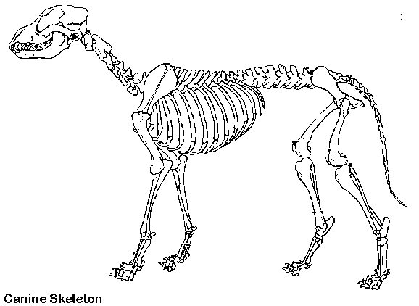

A

D

C

* 1. Skull c. Pelvis

B

* 1. Scapula d. Vertebrae

1. What does the label B represent on the Canine skeleton?
2. Tibia c. Femur
3. Fibula d. Humerus
4. What does the label C represent on the Canine skeleton?
   1. Radius c. Pelvis
   2. Ulna d. Fibula
5. What does the label D represent on the Canine skeleton?
6. Ribs c. Skull

E

1. Vertebrae d. Pelvis
2. What does the label E represent on the Canine skeleton?
   1. Phalanges c. Tibia
   2. Scapula d. Ulna
3. A Collie is in what grouping of dogs
   1. Working c. Toy
   2. Herding d. Sporting
4. Which of the following breeds is in the Non-Sporting group?
   1. Pug c. Labrador
   2. Poodle d. German Shepherd
5. Bone is made up of:
   1. Calcium, phosphorus, and collagen fibers c. Marrow, cartilage and tendons
   2. Vitamins A, B, and C d. Nitrogen, phosphorus and potassium
6. What is the function of bone marrow?
   1. Produces blood cells. c. Provides movement
   2. Provides support d. All of the above
7. Where is bone marrow found?
   1. In the hollow shaft of long bones c. In the hollow shaft of short bones
   2. In the hollow shaft of flat bones d. In the hollow shaft of joints
8. X-rays are used to take a special photograph called a
   1. Photograph c. X-ray
   2. Radiograph d. Bone scan
9. Swine and Humans have what type of digestive systems?
   1. Monogastric c. Ruminant
   2. Monogastric rumination d. Polygastric
10. Rabbits and Horses have what type of digestive system?
    1. Avian digestion c. Hindgut fermenter
    2. Hindgut rumination d. Ruminant
11. Cattle have what type of digestive systems?
    1. Monogastric c. Hindgut Fermenter
    2. Ruminant d. Monogastric Rumination
12. Which one of these digestive organs is found only in the bird?
    1. Cecum c. Crop
    2. Stomach d. Gall Bladder
13. The muscular tube connecting the mouth to the stomach is called the
    1. Stomach c. Pharynx
    2. Esophagus d. Trachea
14. The majority of absorption of nutrients in non-ruminants takes place here
    1. Stomach c. Omasum
    2. Rumen d. Small Intestine
15. The major role of this organ in the digestive process is to provide bile salts to the small intestine and detoxify the blood.
    1. Gall Bladder c. Liver
    2. Pancreas d. Kidney
16. Simple stomachs are called
    1. Monogastrics c. Ruminants
    2. Singular Stomachs d. Gastritis
17. In the ruminant which compartment of the stomach looks like a honeycomb
    1. Abomasum c. Cecum
    2. Reticulum d. Rumen
18. Continuous regurgitation, chewing and swallowing is called
    1. Digestion c. Eructation
    2. Rumination d. Mastication
19. Very muscular organ, used to grind food in birds is called the
    1. Crop c. Beak
    2. Gizzard d. Proventriculus
20. Wavelike motions that propel food through the esophagus are called what?
    1. Peristalsis c. Eructation
    2. Rumination d. Anastalsis
21. How many stomach compartments does a cow have?
    1. One c. Three
    2. Two d. Four
22. What is mastication and why is it important?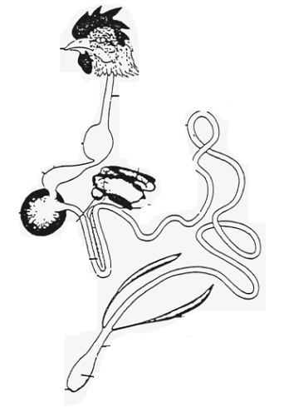

B

* 1. Chewing; to increase surface area of food for easier digestion
  2. Chewing; to decrease surface area of food for easier digestion
  3. Swallowing; to increase wavelike motions
  4. Swallowing; to decrease wavelike motions

1. This is produced excessively in anticipation of food.
   1. Bile c. Mucous
   2. Saliva d. Acid
2. What does the label B represent on the Avian digestive system?
   1. Crop c.Gizzard
   2. Proventriculus d.Ceca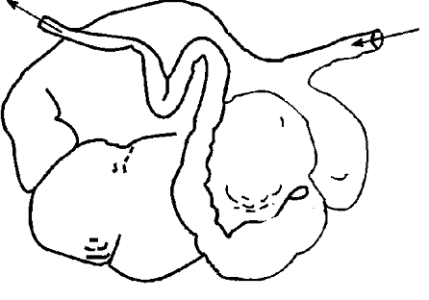
3. What does the label A represent on the Ruminant digestive system?
   1. Abomasum c. Rumen

A

* 1. Omasum d. Reticulum

1. What does the label C represent on the Monogastric digestive system?

C

C

* 1. Pancreas c. Large Intestine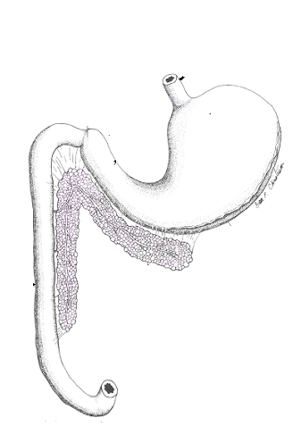
  2. Stomach d. Liver

1. What does the label D represent on the Hindgut fermenter digestive system?
   1. Cecum c. Stomach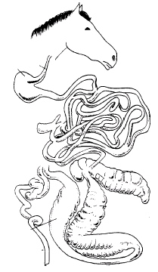
   2. Large Intestine (Colon) d. Rumen
2. What is the main function of carbohydrates?
   1. Growth and repair of cells c. Assist in taste recognition
   2. Provide Energy d. Medium for chemical reactions

D

1. Accounts for 70% or more of the composition of animals?
   1. Blood c. Fat
   2. Skin d. Water
2. Corn, wheat, oats, and barley are considered what type of carbohydrates?
   1. Protein carbohydrates c. Simple Sugar
   2. Fatty carbohydrates d. Starch
3. Which nutrient contains the greatest amount of energy?
   1. Water c. Fats
   2. Minerals d. Vitamins
4. This nutrient is essential because it is needed throughout life for growth and repair and is used for energy only if needed.
   1. Carbohydrates c. Fats
   2. Protein d. Minerals
5. Which of the following is a fat-soluble vitamin?
   1. Vitamin C c. Vitamin B6
   2. Vitamin A d. Vitamin B12
6. Which of the following is a water-soluble vitamin?
   1. Vitamin E c. Vitamin A
   2. Vitamin D d. Vitamin C
7. Protein consists of strings of building blocks called?
   1. Amino chains c. Acetic acids
   2. Amino acids d. RNA
8. Which of the following is a trace mineral?
9. Zinc c. Calcium
10. Sodium d. Phosphorus
11. Which of the following is a macro mineral?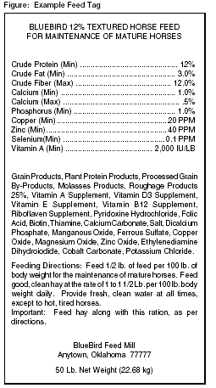

B

* 1. Sodium c. Copper
  2. Zinc d. Selenium

1. Label A represents what on the example feed tag?
   1. Name of Feed
   2. Use of Feed

C

* 1. Ingredients
  2. Manufacturer

1. Label B represents what on the example feed tag?
   1. Guaranteed Analysis c. Use of Feed
   2. Name of Feed d. Manufacturer
2. Label C represents what on the example feed tag?
   1. Use of Feed c. Ingredients
   2. Manufacturer of Feed d. Manufacturer
3. The entire coat of wool shorn from the sheep at one time is called
   1. Fiber c. Fleece
   2. Staple d. Wool

A

1. What does the label A represent on the sheep?
   1. Loin c. Wither
   2. Hip d. Neck
2. What does the label B represent on the sheep?
   1. Poll c. Muzzle
   2. Face d. Neck

B

1. What does the label C represent on the sheep?

A

* 1. Twist c. Loin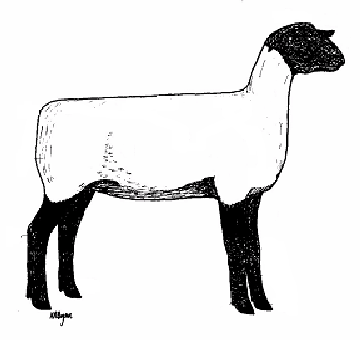
  2. Dock d. Rump

C

1. What does the label D represent on the sheep?
   1. Cannon Bone c. Hoof
   2. Pastern d. Hock
2. What is the purpose of the marking harness?

D

* 1. Identifies which rams are ready for breeding
  2. Provides a signal of which ewes were bred and when
  3. For cosmetic purposes
  4. Identifies which ewes are ready for breeding

1. What is the purpose of docking the tails of sheep?
   1. Sheep do not have tails naturally.
   2. To help keep the sheep clean from manure
   3. For appearance only
   4. In order to show sheep at shows
2. What does the label A represent on the chicken?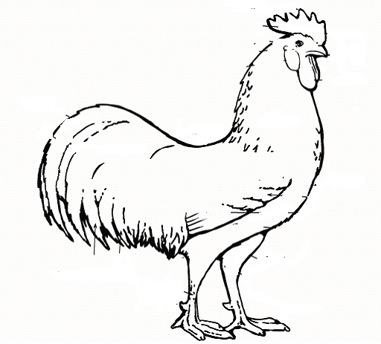

D

A

* 1. Breast

B

* 1. Wattle
  2. Comb
  3. Saddle

1. What does the label B represent on the chicken?

E

* 1. Breast c. Comb
  2. Wattle d. Saddle

1. What does the label D represent on the chicken?
   1. Breast c. Comb
   2. Wattle d. Saddle
2. What does the label E represent on the chicken?
   1. Breast c. Comb
   2. Wattle d. Saddle
3. Chickens raised for meat production are called:
   1. Cornish Game c. Broilers
   2. Layers d. Poultry
4. When chicks become too hot they:
   1. They lay down or pile into corners of the brooder
   2. They chirp a lot and huddle together
   3. They are evenly spaced under the heat lamp

C

* 1. They chirp a lot and pile into the corners of the brooder

A

1. What does the label A represent on the hog?
   1. Ham c. Loin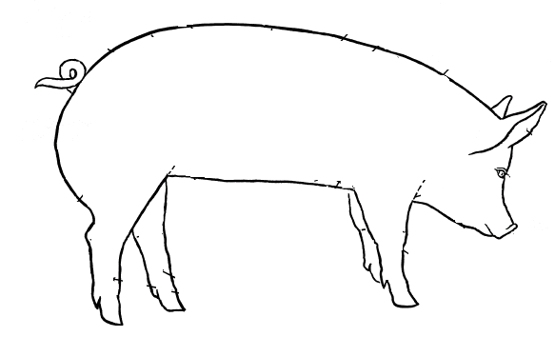
   2. Jowl d. Stifle
2. What does the label B represent on the hog?
   1. Ham c. Jowl
   2. Rump d. Back
3. What does the label C represent on the hog?
   1. Ham c. Stifle
   2. Rump d. Back

B

1. In the universal ear notching system of hogs, what does the right ear number represent?
   1. Individual Pig number c. Litter number
   2. The Sows number d. Number of piglets in the litter
2. Name the type of hog operation that raises hogs from birth to slaughter weight
   1. Breeding Stock c. Finishing Operations
   2. Farrowing Operations d. Farrow to Finish
3. Name the type of hog operation that purchases weaned piglets and raises them to market weight
   1. Seedstock c. Finishing Operations
   2. Farrowing Operations d. Farrow to Finish

*Sassy is an 18-month-old (1 ½ years) female horse who measures 10 hands. Please answer the following three questions regarding Sassy.*

1. How many inches is Sassy?
   1. 14 inches c. 40 inches
   2. 24 inches d. 42 inches
2. At this size what type of horse would Sassy be considered
   1. Horse c. Pony
   2. Short Horse d. Draft
3. According to her age and sex Sassy would be called a?
   1. Filly c. Stallion
   2. Mare d. Gelding
4. Measurement term used in horses from ground to withers.
   1. Foot c. Yard
   2. Hand d. Inches
5. A pony cannot be greater than:
   1. 14 hands c. 12 hands
   2. 14.2 hands d. 10 hands
6. The breed of horse commonly used for harness racing in Michigan.
   1. Quarter horse c. Standardbred
   2. Thoroughbred d. Arabian
7. What does the label A represent on the horse?
   1. Shoulder c. Forearm
   2. Chest d. Neck
8. What does the label B represent on the horse? 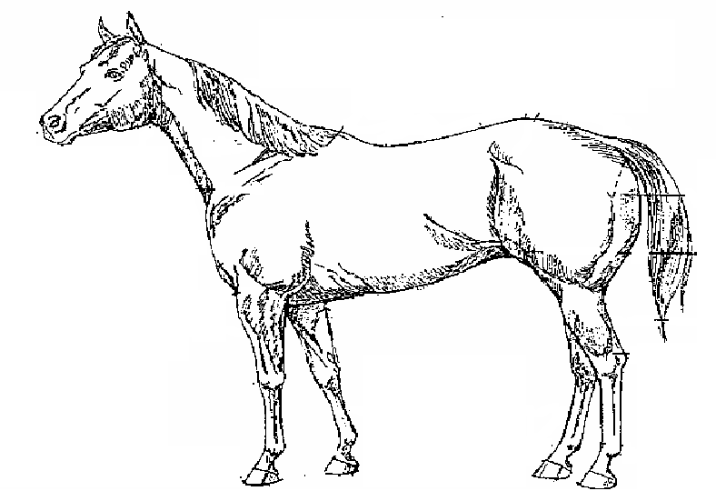

C

E

D

* 1. Gaskin c. Pastern
  2. Cannon bone d. Coronet

A

1. What does the label C represent on the horse?
   1. Withers c. Loin
   2. Croup d. Hock

B

1. What does the label D represent on the horse?
   1. Loin c. Back
   2. Croup d. Withers
2. What does the label E represent on the horse?
   1. Stifle c. Fetlock
   2. Gaskin d. Croup
3. The term for away from the midline is
   1. medial c. Proximal
   2. lateral d. Distal
4. The term that refers toward the back area or above is
   1. ventral c. cranial
   2. dorsal d. caudal
5. The term that means toward the head is
   1. ventral c. cranial
   2. dorsal d. caudal
6. Disease of heart muscle is
   1. Cardiopathy c. cardiovalvopathy
   2. cor pulmonale d. cardiomyopathy
7. Heart enlargement is
   1. cardiac swelling c. cardiac dilation
   2. cardiac augmentation d. cardiomegaly
8. The blood vessels that carry blood from the heart to the lungs are the
   1. pulmonary veins c. vena cava
   2. pulmonary arteries d. aorta
9. The contraction phase of the heartbeat is the
   1. septum c. systole
   2. diastole d. tachycardia
10. The myocardium receives its blood supply from the
    1. aorta c. vena cava
    2. coronary arteries d. subclavian artery
11. The organism that causes heartworm is:
    1. *Dirofilaria immitis c. Giardia*
    2. *Taenia pisiformis* d. Protozoa
12. The most common endoparasite of puppies and kittens is:
    1. Flea c. mite
    2. Roundworm d. protozoa
13. What parasite transmits Lyme disease?
    1. *Dirofilaria immitis* c. Lice
    2. Heartworm d. Tick
14. To remove a tick you should:
    1. Use a match to burn the tick off c. Pour alcohol on the tick, then pull it off
    2. Cut the tick off with a knife d. Use tweezers to grasp the head and pull straight out
15. Label this external parasite.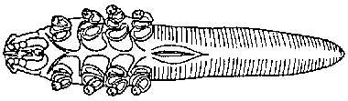
    1. Flea c. Walking Dandruff
    2. Demodex d. Ear mite
16. Which phylum does the flea belong to:
    1. Platyhelminthes c. Arthropoda
    2. Nematoda d. Sacrodina
17. Which of the following is not a mite?
    1. Otodectes c. Demodex
    2. Cheyletiella d. Ixodes
18. What is the intermediate host of Dipylidium?
    1. Mice c. Ticks
    2. Flea d. Mite
19. The suffix -cyte means
    1. Cell c. Breathing
    2. Water d. Disease
20. The abbreviation ‘stat’ means
    1. Difficulty c. New
    2. Immediately d. Many
21. The prefix ‘Hydr/o’ means
    1. Ear c. Water
    2. Lake d. Eating/swallowing
22. The abbreviation ‘DOB’ means
    1. Date of Belonging c. Date of Birth
    2. Death of Bunny d. Dead on Birth
23. The abbreviation ‘DSH’ means
    1. Domestic Short Hair c. Do Save Horse
    2. Dog Short Hair d. Domestic Soft Hair
24. The suffix ‘–lysis’ stands for what
    1. Pertaining to c. Deficiency of
    2. Destruction of d. Many
25. The suffix ‘–penia’ stands for what
    1. Pertaining to c. Deficiency of
    2. Destruction of d. Many
26. The abbreviation ‘ml’ also could be stated as
    1. cl c. cd
    2. cc d. mc
27. The term ‘ad lib’ means
    1. Many c. as many as you want
    2. pertaining to d. in the water
28. The prefix ‘post’ means
    1. before c. after
    2. during d. next day
29. The hormone testosterone is produced by the:
    1. Epididymis c. Scrotum
    2. Leydig cells d. Seminiferous Tubules
30. The hormone that is produced by the developing follicles on the ovary.
    1. Estrogen c. Progesterone
    2. Prostaglandins d. Testosterone
31. Meiosis in male for sperm production takes place here:
    1. Prostate c. Epididymis
    2. Seminiferous tubules d. Vas deferens
32. Prostaglandins are released from what organ if fertilization does not take place.
    1. Uterus c. Infundibulum
    2. Oviduct d. Ovary
33. Name the stage of estrous in which the egg is released into the infundibulum.
    1. Proestrus c. Metestrus
    2. Estrus d. Diestrus
34. Squeeze chutes are a form of restraint most often used with _______________.
    1. Cattle, horses, and sheep c. Cats and dogs
    2. Cats d. reptiles
35. __________________ is a steam-pressure sterilizer that uses heat to destroy microorganisms on instruments.
    1. A retort c. An asepsis
    2. A radiator d. An autoclave
36. The root word or combining form of the medical term that refers to the lung is __________.
    1. Derm or dermat c. Pulmo or pulmon
    2. Cardi d. Thorac
37. Docking is the removal of an animal’s _______________.
    1. Testicles c. Horns
    2. Tail d. Claws
38. Baby dogs are born in groups of 1 to 10 puppies, known as ____________________.
    1. Broods c. Litters
    2. Orphans d. Bitches
39. _________________ exams are often used to determine the presence of internal parasites in dogs.
    1. Fecal c. Ear
    2. Mouth d. Skin
40. Which type of tissue covers body surfaces and lines body cavities as skin?
    1. Nervous tissue c. Muscular tissue
    2. Connective tissue d. Epithelial tissue
41. Bone that has the appearance of visible spaces within it is known as _________ bone.
    1. Cancellous c. Haversian
    2. Woven d. Compact
42. The study of the functions of the cells, tissues, organs, and systems of an organism is _______________.
    1. Anatomy c. Homeostasis
    2. Physiology d. Botany
43. Cell ______________ is the differences that allow cells to perform unique activities.
    1. Multiplication c. Division
    2. Physiology d. Specialization
44. A cat should be ___________ to protect it against diseases such as rabies and feline leukemia.
    1. Spayed c. Vaccinated
    2. Neutered d. Washed
45. Which of the following is a multicellular organism that lives in or on another animal, from which it receives its nutrients?
    1. A bacteria c. A protozoa
    2. A parasite d. A virus
46. A *balling gun* is used to deliver medications ______________.
    1. Orally c. Topically
    2. Rectally d. Subcutaneously
47. _______________ are immune substances produced in the body, allowing animals to withstand exposure to disease.
    1. Biologicals c. Antibodies
    2. Disinfectants d. Antibiotics
48. Which of the following types of disease is related to a physical injury to the animal?
    1. Contagious c. Morphological
    2. Nutritional d. Physiological
49. Soaking items in a chemical disinfectant until they are used is called ___________.
    1. Ultrasound c. Filtration
    2. Cold sterilization d. Cleaning
50. Removing particles from the air using physical barrier is called _________.
    1. Ultrasound c. Filtration
    2. Cold sterilization d. Cleaning
51. Passing high frequency sound waves through a solution to create a vibration that scrubs an object to remove debris is called ____________________.
    1. Ultrasound c. Filtration
    2. Cold sterilization d. Cleaning
52. ___________ are biohazard materials such as needles, scalpel blades, and syringes that must be disposed of in red, sealed containers labeled with the biohazard symbol.
    1. Radioactive material c. MSDS
    2. Dosimeters d. Sharps
53. ____________________ lists information about a chemical including manufacturer information, hazard ingredients, physical and chemical characteristics, fire and explosion hazard data, health hazard data, precautions for safe handling and use and control measures.
    1. Pesticide Label c. Inventory Sheet
    2. Material Safety Data Sheet d. Order sheet
54. To remove a tick you should ______________.
    1. Use a match to burn the tick off c. Pour alcohol on the tick, then pull it off
    2. Cut the tick off with a knife d. Use tweezers to grasp the head and pull straight out
55. The clinical signs of heartworm are: __________.
    1. Vomiting, deep cough, anemia c. Deep cough, irregular heartbeat, exercise intolerance
    2. Anemia, deep cough, irregular heart beat d. irregular heartbeat, anemia, exercise intolerance
56. One disease that is transmitted by the tick is called _________.
    1. Rocky Mountain Spotted Fever c. Salmonella
    2. Toxoplasmosis d. Ringworm
57. What parasite transmits Lyme disease?
    1. *Dirofilaria immitis* c. Lice
    2. Heartworm d. Tick
58. The organism that causes heartworm is called _________.
    1. *Dirofilaria immitis c. Giardia*
    2. *Taenia pisiformis* d. Protozoa
59. The most common endoparasite of puppies and kittens is called _________.
    1. Flea c. Mite
    2. Roundworm d. Protozoa
60. Cats are ______________.
    1. Omnivores c. Obligate carnivores
    2. Hindgut fermenters d. Mild drinkers
61. The genus and species of the horse is ____________.
    1. Equus caballus c. Canis familiaris
    2. Equine d. Bos indicus
62. Which is largest?
    1. 700 gramsc. 7 ounces
    2. 7 pounds d. 7 kilograms
63. Which species is not social and should always be kept out of contact from each other?
    1. Hamsters c. Rats
    2. Rabbits d. Guinea pigs
64. What is not a class of restraint?
    1. Chemical c. Physical
    2. Social d. Psychological
65. A frightened dog might display which of the following behaviors?
66. Scanning the area and not paying attention to owner c. Growling
67. Hiding behind the owner d. All of the above
68. What learning method are you employing when you remove an unpleasant stimulus after the animal does what you’ve asked?
    1. Positive punishment c. Positive reinforcement
    2. Negative punishment d. Negative reinforcement
69. “Hard pad” disease is also known as _____________.
    1. Distemperc. Laminitis
    2. Calicivirus d. Arthritis
70. Which breed is bigger?
    1. Quarter horse c. Percheron
    2. Hackney d. Thoroughbred
71. A “Coggins test” checks for _______________.
    1. Equine Infectious Anemia c. Coggins Disease
    2. Equine Protozoal Meningitis d. Herpes
72. Which of the following characteristics make horses unique among other agricultural species?
    1. Can’t vomit c. Produce more liver enzymes
    2. A and D d. No gallbladder Produce more liver enzymes
73. Which of the following is not considered a reportable disease in Michigan?
    1. Johne’s c. Sleeping sickness
    2. Rabies d. FIV
74. Which of the following is considered a zoonotic disease?
    1. Leptospirosis c. Distemper
    2. Pneumonia d. Azoturia
75. How many upper incisors would a 4-year-old ram have?
    1. 0 c. 6
    2. 4 d. 12
76. The herding group of dogs is known for their high need of:
    1. Grooming c. Attention from strangers
    2. Activity and exercise d. Food
77. What species has the shortest estrous cycle length?
    1. Cattle c. Sheep
    2. Swine d. Horses
78. Where are most nutrients absorbed in monogastrics?
    1. Stomach c. Rumen
    2. Large intestine d. Small intestine
79. What is supplemented as an injection to newborn piglets because their needs are higher than what is found in milk?
    1. Iron c. Vitamin B
    2. Magnesium d. Colostrum
80. When giving an IM injection to cattle, what site is usually preferred?
    1. Neck c. Jugular Vein
    2. Gluteal muscle d. Loin
81. Where can you find an operculum?
    1. Rabbit mouth c. Horse hoof
    2. Fish gills d. Cattle Stomach
82. Which of the following has a mane and tail the same color as the body?
    1. Palomino c. Chestnut
    2. Bay d. Dun
83. The common name of the distal phalanx is:
    1. Short pastern c. Splint
    2. Coffin d. Stifle
84. Which disease is there not a vaccination available for?
    1. Strangles c. Tetanus
    2. West Nile Virus d. EPM
85. A horse with heaves can be most helped by:
    1. Keeping them indoors c. Reducing dust exposure
    2. Regular exercise d. Regular hoof trims
86. Which two disorders causes the greatest problems in rats?
    1. Mammary tumors and respiratory infections c. Cancer and bloat
    2. Bloat and scours d. Snuffles and colic
87. A horse is seen standing with its weight shifted back off its front feet. His feet are hot to the touch. What problem could this horse have?
    1. Laminitis c. Lameness
    2. Colic d. Fever
88. Cryptorchidism is seen in:
    1. Stallions c. Gilts
    2. Mares d. Pullets
89. What animal uses their lateral line as a sensory organ?
    1. Fish c. Sugar Gliders
    2. Iguanas d. Frogs
90. All licensed veterinarians are allowed to _________ wild animals like raccoons and foxes.
    1. Rehabilitate c. Raise as pets
    2. Euthanize d. Capture and neuter
91. A new disease is reported to have a high morbidity rate. What does that mean?
    1. Many animals die c. Many animals get sick
    2. A few animals die d. A few animals get sick
92. Which is not used to estimate a horse’s age by teeth?
    1. Galvayne’s groove c. Angle of teeth
    2. Tartar accumulation d. Cups and stars
93. What water quality parameter is not regularly tested in fisheries?
    1. Nitrate c. Ammonia
    2. Nitrate d. Acetic acid