**FFA Dairy Handling Guide**

Natalie Holbrook

November, 2020

**Table of Contents**

**Student Worksheets**

**p. 3** Section 1: Introduction to Dairy, Dairy Handling, and Dairy Evaluation

**p. 9** Section 2: Showmanship Basics

**p. 11** Section 3: Making the Animal Look its Best

**p. 13** Section 4: If Your Animal is Acting Up

**p. 14** Section 5: Preparing and Presenting Yourself for Show

**Answer Keys**

**p. 16** Section 1: Introduction to Dairy, Dairy Handling, and Dairy Evaluation

**p.18** Section 2: Showmanship Basics

**p. 19** Section 3: Making the Animal Look its Best

**p. 20** Section 4: If Your Animal is Acting Up

**p. 21** Section 5: Preparing and Presenting Yourself for Show

**Appendices**

**Appendix A** Dairy Cattle Unified Scorecard

**Appendix B** Michigan Farm Bureau Regional Representatives Map

For additional information on training, fitting, and showing Dairy Cattle, check out the Holstein Foundation’s *Showring Ready: A Beginner’s Guide to Showing Dairy Cattle*

<http://www.holsteinfoundation.org/pdf_doc/workbooks/Showring_Ready_Workbook.pdf>

*Purebred Dairy Cattle Association Showmanship Evaluation Card* <http://www.purebreddairycattle.com/file_open.php?id=6>

Section 1: Introduction to Dairy, Dairy Handling, and Dairy Evaluation

Key Question: What is the purpose of Dairy Handling?

**Terminology:** Be sure to define the following terminology prior to watching the videos.

* Cow
* Heifer
* Showmanship
* Halter
* Lead of halter
* Set up
* Fore Udder
* Rear Udder
* Fit/fitting
* Clipping
* Topline
* Barrel
* Broken topline
* Withers

**What is the purpose of Dairy Animals?**

It’s important to keep in mind what dairy cattle are used for. Unlike beef cattle, meat is NOT the main purpose for dairy cattle. This means that we want our dairy cattle to look very different from beef cattle! When evaluating dairy cattle, we want to think about how good they would be for producing milk and having calves. Dairy cattle should not be heavy-muscled or have very much fat, their energy should be going to milk production rather than packing on weight. How well an animal will perform as a milk cow and how well she can carry and birth a calf are the major considerations that led to the breakdown of the Dairy Cattle Unified Scorecard.

Take a look at the Dairy Cattle Unified Scorecard (Appendix A). Which category emphasizes the difference between dairy cattle and other cattle (such as beef cows)? Explain.

**Why do we show cattle?**

We show cattle for the purpose of evaluating them. Why do we evaluate dairy cattle?

We evaluate cattle for several reasons. One of the main reasons is to determine who we would want to breed her to. If we evaluate a cow and determine that she’s really weak in her pasterns, we would want to breed her to a bull that has strong pasterns in hopes of correcting that weakness in the cow’s offspring. Evaluating cattle also helps us determine if and how many offspring we may want from a cow or heifer. If a cow is evaluated and it is decided she has very valuable genetics, a farmer may “flush” that cow, meaning they will flush eggs from her that can then be implanted in other cattle. This allows a really good cow to have far more offspring than she could carry on her own. A farmer can also evaluate cattle as a way to determine what cows or heifers should be sold off from the herd.

What does it mean to evaluate dairy cattle?

Evaluate the cow pictured below.

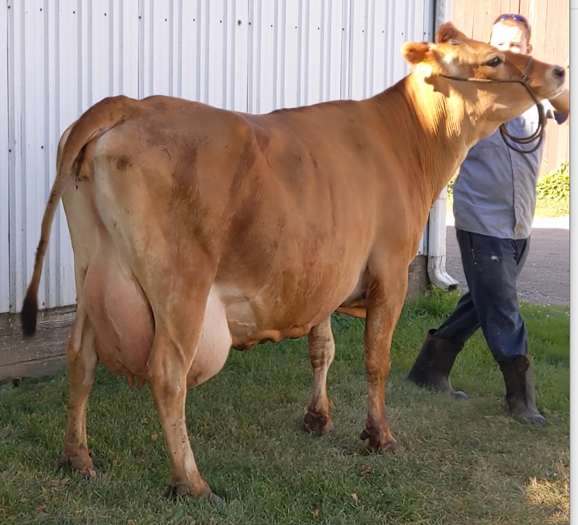

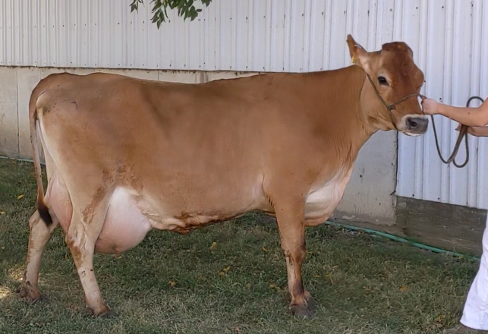

What are some of her strengths? What are some of her weaknesses?

**What to do next:**

* Practice your cow parts! On both diagrams and live cattle
* Practice evaluating cattle; talk to a local farmer or use online resources
  + LivestockJudging.com
  + Hoards.com and Hoard’s Dairyman Magazine
  + Virginia Tech Dairy Cattle Judging YouTube: <https://www.youtube.com/channel/UCNRhuG51jwgcPVkExTScg8w>
  + Holstein Foundation Dairy Judging Workbook: <http://www.holsteinfoundation.org/pdf_doc/workbooks/Dairy_Judging_Workbook.pdf>
* If you are taking part in the Michigan FFA Dairy Cattle Showmanship Contest, you will be given an animal to show on show day rather than picking your own animal in advance
  + Contact a local dairy farmer, preferably one that has show cattle, and ask if you can practice with any of their cows and/or heifers
    - If you’re unsure of how to get a hold of a dairy farmer near you, start by contacting your Farm Bureau Regional Rep (see Appendix B). They should be able to help you find a farm to work with.
* If you’re choosing an animal for yourself to show…
  + You can pick from your own herd
  + Or you can work with a local dairy farmer to find an animal for you to show
* When choosing a heifer or cow…
  + Evaluate her! How does this heifer or cow line up against the Dairy Cattle Unified Scorecard (Appendix A)?
  + What size heifer or cow do you want to show? Think about your own size and consider heifers or cows within an age group that would not look too big or too small for you.
    - Ex: someone who is really tall can look out of place showing a little Spring Heifer Calf
  + Consider her birthdate. Look at the class breakdowns for your show and try to choose a heifer that will be at the older end of the range
    - Ex: a Winter Heifer Calf was born between Dec.1 and Feb. 29 of the year of the show. If you are looking at a heifer within this age range, you would want to find one closer to Dec. 1. A calf born in February is going to look very small next to a calf born in December, putting you at a disadvantage.
* Once you’ve chosen your animal…
  + Get an appropriately sized rope halter - remember to look at the nose piece when determining sizing
  + Work with someone who is familiar with cattle in order to catch her with the rope halter
  + Start by simply tying her up and getting her used to your presence; keep a hand on her back, pet her, brush her, and work your way up to her face
    - Don’t overwork your animal, keep it to under an hour
  + Once she seems comfortable around you, you can move on to training

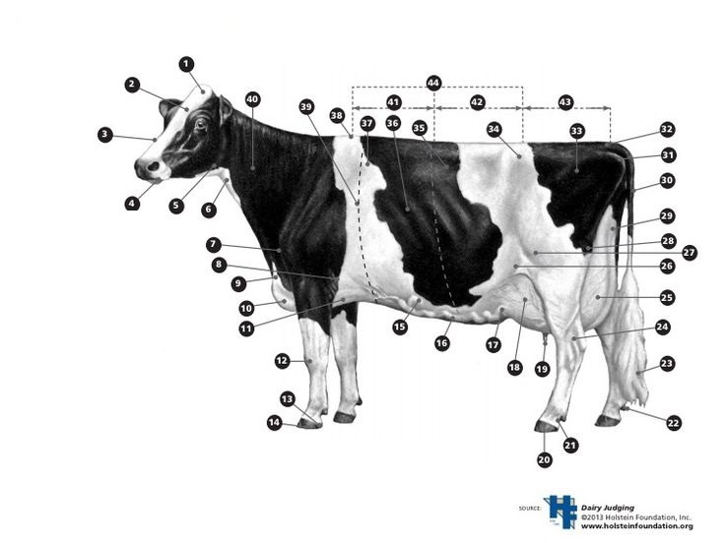

Section 2: Showmanship Basics

Key Objective: for students to be able to describe the skills and techniques used for haltering, walking, and setting up both a dairy cow and a dairy heifer.

Watch the video Dairy Showmanship Basics: **PASTE YOUTUBE LINK HERE**

In this video, learn about different types of halters, how to switch between halters, and how to hold a halter. Learn how to walk when showing your animal and different techniques for setting up your animal. Be sure to pay attention to the differences between cows and heifers!

Why should you not wrap the lead around your hand?

Why do you walk clockwise?

Explain the reasons for keeping an animal’s distance.

Why are cows set up differently from heifers?

Why do you think these techniques are used for showing dairy?

**What to do next:**

* Once your animal is comfortable with you and a halter, you can begin training her
  + When you first begin training, use a rope halter
  + Start with walking. If your animal has never been shown before, it will likely take her time to get used to walking on a halter. Don’t just constantly pull; use gentle, short, tugs and reward her with pets and scratches when does take a few steps
  + Remember not to overwork your animal, 30 minutes a day is plenty of time when training your animal
* Once your animal is comfortable with walking…
  + Remember to practice a good pace and keep her head up
    - When showing dairy cattle you generally walk at a slow pace; this is different from showing beef cattle where you would walk at a more moderate speed
  + Try walking her in different areas so she gets used to new environments
  + Practice trying to set her up, your goal is to be able to walk her into a set up position
  + Practice backing her up with backwards pressure on her shoulder or halter

Section 3: Making the Animal Look its Best

Key Objective: For students to be able to describe techniques to make their animal look its best during show.

Watch the video *Making the Animal Look its Best*: **PASTE YOUTUBE LINK HERE**

In this video, learn some techniques you can use to make your animal look its best including: how you fit your animal, pulling throat, fixing her topline, how to set her up, and where to set her up. In order for this video to be beneficial to you, you must have an understanding of evaluating your own animal. Once you determine your animal’s weaknesses, the methods shown and described in this video can potentially help you hide these during the show. Keep in mind that these techniques are only meant to fix minor problems with your cattle! It’s key to start with a heifer or cow that already excels in most areas of the Dairy Cattle Unified Scorecard.

Another thing to keep in mind while watching the video is that most of these improvement techniques are demonstrated on the same heifer; it may look different on this heifer than it does for your animal. For example, this heifer does *not* naturally want to set up short and so the difference of setting up “too short” versus setting up correctly may not be as obvious on her as it would on a heifer that *does* naturally set up short. In general, every animal is going to look different in where they need improvement and how exactly they should be set up. Be sure to closely evaluate your own animal; it can be helpful for someone to take a picture or video of your animal while you are showing her so then you can see how she’ll look to a judge.

What does it mean to “pull throat?” What is the purpose? What category of the Dairy Cattle Unified Scorecard does this relate to?

Is it possible to set up your animal too long? Explain. What category of the Dairy Cattle Unified Scorecard does this relate to?

What should you do if the judge walks around to your side of the animal? Why should you do this?

Why is it important to pay attention to where in the ring you set up your animal?

Look back at the cow from Section 1 and what you listed as her strengths and weaknesses. How can you fix her weaknesses during show? Can you emphasize her strengths?

**What to do next:**

* If you are taking part in the FFA Dairy Cattle Showmanship Contest where you are given an animal: Practice evaluating cattle
  + Evaluate the animal you’ve been practicing with to determine her weaknesses. Hopefully you did this prior to picking your animal, but it is always important to determine her strengths and weaknesses. Additionally, heifers grow and change over time so it is possible her strengths and weaknesses have changed.
  + Plan out how you could make her look better during a show and practice these techniques.
  + Since you don’t know what type of animal you’ll be given at the FFA Contest, practice evaluating and “improving” a variety of heifers and cows.
* If you are showing an animal you’ve picked out: Evaluate your animal!
  + Hopefully you did this prior to picking your animal, but it is always important to determine her strengths and weaknesses. Additionally, heifers grow and change over time so it is possible her strengths and weaknesses have changed.
  + Once you’ve determined where you animal needs improvement, plan out how you can make her look better during show
    - This may involve how you clip her hair, fixing her topline, pulling throat, setting her up a certain way, or any number of things to improve her overall appearance.
    - P. 13-17 of the *Showring Ready* Guide from the Holstein Foundation goes into detail on fitting cattle: <http://www.holsteinfoundation.org/pdf_doc/workbooks/Showring_Ready_Workbook.pdf>

Section 4: If Your Animal is Acting Up

Key Objective: Students will be able to describe what to do if their animal is acting up during a show

Watch the video *If Your Animal is Acting Up*: **PASTE YOUTUBE LINK HERE**

If you are showing an animal you chose, hopefully you’ve trained her well enough that you don’t have any issues. If you are showing an animal given to you at the FFA Dairy Cattle Showmanship Contest, hopefully that animal has been trained well enough by her owner that you don’t have any issues. However, cattle can be unpredictable and shows are a strange, new environment. In this video, learn what to do if your animal moves out of line, if she is tossing her head or being aggressive, and if she urinates or defecates while in the ring.

Why is it important to always turn your animal away from you?

Why does a heifer’s nose matter when she’s turning?

If your animal is really acting up, what should you do?

What should you do if your animal urinates during the show?

What is something you could do to prepare for the possibility of your cow defecating during a show?

**What to do next:**

* Train with your animal regularly!
* Walk your animal in a variety of environments to get her used to the unexpected
* If possible, find other showman that you can train with in order to get your animal used to walking with other cattle

Section 5: Preparing and Presenting Yourself for Show

Key Objective: students will be able to describe how to prepare themselves and present themselves for a dairy show

Watch the video *Preparing and Presenting Yourself for Show*: **PASTE YOUTUBE LINK HERE**

In this video, learn what you can do before a show to prepare for showmanship as well as what you should be doing during a show to be a better showman. A good showman balances between watching the judge and watching their calf, don’t get distracted by other showmen or what’s going on outside of the ring! You also want to be confident and poised without overshowing or appearing stiff. Prior to showmanship, you want to be well groomed and have the appropriate show attire. Lastly, make sure you are knowledgeable about dairy cattle, the dairy industry, and your animal specifically. If you are taking part in the FFA Dairy Cattle Showmanship Contest, questions may include: breeds of dairy cattle, cow parts, and general showring knowledge.

Why is it important to keep an eye on the judge during a show?

Describe what you should wear when showing dairy.

Why do you think confidence makes a difference in the showring?

Why is how you look important when showing?

Why do you think a judge usually asks questions during showmanship?

**What to do next:**

* Finding Dairy Whites can be difficult, don’t wait until the last minute to purchase white pants!
  + White pants should fit over your boots rather than be tucked in
  + White shirts should preferably have a collar
* Before a show, make sure you have everything you need to get you and your animal ready
  + Make sure your Dairy Whites fit comfortably and are clean
  + Make sure you have a plan of what you need to do in order to make yourself appear presentable
    - Will you need to shave? Will you need to pull your hair back? Etc.
  + Collect all of the supplies you need in order to fit your animal
    - P. 13-17 of the *Showring Ready* Guide from the Holstein Foundation goes into detail on fitting cattle: <http://www.holsteinfoundation.org/pdf_doc/workbooks/Showring_Ready_Workbook.pdf>
* Prepare for questions
  + Know your animals strengths and weaknesses! “What would you change about her?” is a common question
  + Study the parts of a cow
  + Study basic knowledge about dairy cattle, such as how many stomach compartments they have and what the characteristics are of each of the main breeds
  + If you’re showing an animal of your choice, be sure to learn about that animal specifically
    - Examples of heifer questions: How old is she/when is her birthdate? Who is her sire? Is she bred?
    - Examples of cow questions: How old is she/when is her birthdate? When did she last freshen? How many calves has she had? What’s her peak milk production? Is she bred?

Answer Keys

Section 1:

Terminology:

* Cow - Female bovine that has given birth
* Heifer - young female bovine (has not yet given birth)
* Showmanship - a class where participants are judged on their ability to show their animal to its fullest potential
* Halter - a rope or strap that fits over an animal’s face for the purpose of leading the animal or tying her up
* Lead of halter - the portion of the halter that is a loose rope or strap; this is the portion that would be used to tie an animal up
* Set up - setting an animal up means to stop them and position their feet appropriately for that species and animal (ex: a dairy heifer should be set up with her front feet square and her back foot closest to the judge further back than her other back foot)
* Udder - the organ consisting of mammary glands of a cow (the term can be used for other species as well); split into 4 quarters, generally each has its own teat (for cattle)
* Fore Udder - the front (towards her head) two quarters of a cow’s udder
* Rear Udder - the rear two quarters of a cow’s udder
* Fit/fitting - fitting your animal means to do what you can to make her look her absolute best for show; this can include clipping, applying adhesive, teasing her tail, and a variety of other techniques
* Clipping - to cut hair using electric clippers
* Topline - the cow’s back/spine
* Barrel - the main body of the cow, the volume of her rib cage
* Broken topline - if you look across a cow’s back and there is a spot where it “breaks” or dips down unevenly
* Withers - where the shoulder blades meet at the base of the neck

Take a look at the Dairy Cattle Unified Scorecard (Appendix A). Which category emphasizes the difference between dairy cattle and other cattle (such as beef cows)? Explain.

The category Dairy Strength really has two separate parts: dairyness and strength. The dairyness portion of this category is what sets dairy cattle apart from other cattle: she should look long, lean, and feminine with incurving thighs and prominent withers, hips, and pins.

What does it mean to evaluate dairy cattle?

(answers will vary) Evaluating dairy cattle means to judge a cow or heifer’s strengths and weaknesses. This should be done using the Dairy Cattle Unified Scorecard.

Evaluate the cow pictured below. What are some of her strengths? What are some of her weaknesses?

(answers may vary)

Strengths: wide rear udder attachment, defined udder cleft with a strong crease, incurving in her thigh, strong Jersey characteristics

Weaknesses: topline breaks in front of hips, fleshy around her face and pins, short fore udder attachment

Parts of a Dairy Cow:

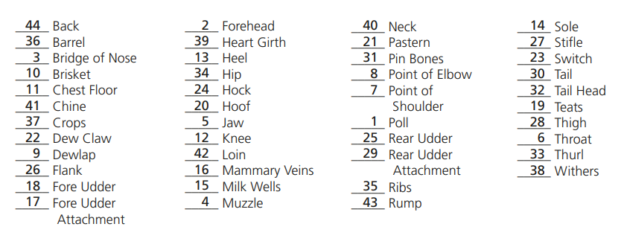

Section 2:

Why should you not wrap the lead around your hand?

If your animal took off running and you had the lead wrapped around your hand, the coil would tighten around your hand possibly breaking it and potentially causing you to be dragged if you couldn’t let go.

Why do you walk clockwise?

This keeps the animal between you and the judge the majority of the time

Explain the reasons for keeping an animal’s distance.

This gives the judge a better view of the animal and is safer. Your animal is less likely to get spooked by a showman or other animal bumping into her from behind and you are less likely to spook the animal in front of you. It also leaves you plenty of space in case you need to turn around.

Why are cows set up differently from heifers?

Cows are set up so that the back leg closest to the judge should be forward, preferably landing right in the middle of the udder. This gives the judge the opportunity to view both the fore and rear udder of the cow from a profile view.

Why do you think these techniques are used for showing dairy?

(answers will vary) You can’t easily switch sides because of the size of the animal and the halter used; you set up in a way to give the judge the best view of the animal; you walk into place because she’s too large for you to move her feet and you aren’t using a showstick; you hold the halter and keep a distance for safety purposes; etc.

Section 3:

What does it mean to “pull throat?” What is the purpose? What category of the Dairy Cattle Unified Scorecard does this relate to?

Pulling throat means to pull the excess skin under her jaw off to the side so that her profile on the judge’s side appears more clean and feminine about her head and neck. This relates to the dairyness portion of the Dairy Strength category on the Dairy Cattle Unified Scorecard.

Is it possible to set up your animal too long? Explain. What category of the Dairy Cattle Unified Scorecard does this relate to?

If you set a cow or heifer with her legs too far back she can look very stretched and it could cause her topline to sag. This problem would mainly fall under the Frame category, but it could also potentially cause her back legs to look incorrect, also marking her down in the Rear Feet and Legs category on the Dairy Cattle Unified Scorecard.

What should you do if the judge walks around to your side of the animal? Why should you do this?

If the judge walks around to your side, you should step towards the front of your animal in order to give the judge a more complete profile view.

Why is it important to pay attention to where in the ring you set up your animal?

You want to preferably find a spot in the ring where you can set up your animal so that her topline runs uphill and her withers are the tallest point of her back. You definitely want to make sure that you don’t set her up to make her look shorter.

Look back at the cow from Section 1 and what you listed as her strengths and weaknesses. How can you fix her weaknesses during a show? Can you emphasize her strengths?

(answers will vary)

You can set her up with her feet a little further beneath her and pull up behind her shoulder to try to get her to straighten her topline. You could also pull throat in order to make her appear cleaner about her head and neck.

You could potentially emphasize the strengths of her rear udder by lightly oiling it to make it stand out.

Section 4:

Why is it important to always turn your animal away from you?

You should turn your animal away from your body for safety purposes. If you turn the animal towards you, it is more likely she can step on your foot and trip you

Why does a heifer’s nose matter when she’s turning?

A heifer (or cow) will generally go wherever their nose points

If your animal is really acting up, what should you do?

Pinch her septum between thumb and forefinger; direct her nose where you want her to go

What should you do if your animal urinates during the show?

First, let her do her business, don’t keep trying to drag her. Once she’s done, use your thumb and forefinger to push her topline back down

What is something you could do to prepare for the possibility of your cow defecating during a show?

Keep a paper towel in your back pocket in case you need to wipe manure off your cow’s udder

Section 5:

Why is it important to keep an eye on the judge during a show?

During the show the judge will motion to you on when to stop and set up, when to begin walking, and when to line up. You also need to know where the judge is in order to set up your animal’s feet properly.

Describe what you should wear when showing dairy.

White collared shirt, white pants (that go OVER the boots), leather boots, a belt

Why do you think confidence makes a difference in the showring?

(answers will vary) Being confident with your animal can help show your animal who’s in charge. Additionally, confidence in the showring can make you look even more like you know what you are doing

Why is how you look important when showing?

You want to look prepared for the show and well-groomed, just like your animal. It looks more professional and like you know what you’re doing if you present yourself properly.

Why do you think a judge usually asks questions during showmanship?

(answers may vary) Questions can help a judge determine how much you know about dairy and how much you yourself put into the project rather than someone such as a parent having done all of the prepwork for you. If you are going to show an animal, it’s important for you to have a base knowledge of that species in addition to knowing specifics in regards to your individual animal.