National Outstanding Achievement Award Application
Revised: 01/16/2025-MMS

Please Note:
- Local Chapters: Submit to your state office in accordance with state deadlines. Application deadlines can be found on the Michigan FFA website at: https://michiganffa.org/association/calendar/. Submit applications on the website at: https://michiganffa.org/awards/outstanding-achievement-award/
- State Associations: Applications should be emailed to alumni@ffa.org or mailed to:
National FFA Organization
C/O Alumni & Supporters
6060 FFA Drive
P.O. Box 68960
Indianapolis, IN 46268-0960
- Applications must be typed.
- No additional pages may be added.
- Keep a copy of the application for your records, as applications will not be returned.
- Recipients may be asked to send a picture for use by the National FFA Organization.
- An activity may be listed only once.
- The FFA Alumni and Supporters Resource Guidebook can be a useful tool for completing the application (can be found at FFA.org/alumni.)
- By submitting this application, you are providing National FFA permission to share the events and programs listed on the application.
- If not selected for this award, you may reapply annually.
- Award recipients may only receive this award once.

Has nominee ever been employed as a teacher, state staff, or teacher educator of agricultural education?

Yes or No?

Name of Nominee:

Mailing Address :

City: |  | State: |  | Zip:

Phone: |  | Ext: |  | Fax:

Phone/Email:

Title or Occupation of Nominee:
Alumni Chapter/Alumni Chapter ID:

Nominated by the state of:

State Alumni Leader Phone/Email:

_______________________________________ _____________________________________
State FFA Alumni President or Executive Director Date Submitted

Involvement (50 points total)

Responses are open to, but not required to be, involvement at the local, state and national levels.

- (10 points) In what ways has the nominee demonstrated outstanding achievement through Business Operations for Alumni and Supporters in the areas of premier leadership and stewardship?

- (10 points) In what ways has the nominee demonstrated outstanding achievement through FFA Alumni and Supporters Member Development in the areas of recruiting new Alumni and Supporters and providing member development opportunities for existing Alumni and Supporters members?

- (10 points) In what ways has the nominee demonstrated outstanding achievement through Advocacy for Agricultural Education in the areas of community support, school officials support and community service?

- (10 points) In what ways has the nominee demonstrated outstanding achievement through Agricultural Education/FFA Program Development in the areas of student recruitment, cooperation, teacher support, and financial support?

- (10 points) In what ways has the nominee demonstrated outstanding achievement through Student Development in the areas of student leadership, personal growth and career success?

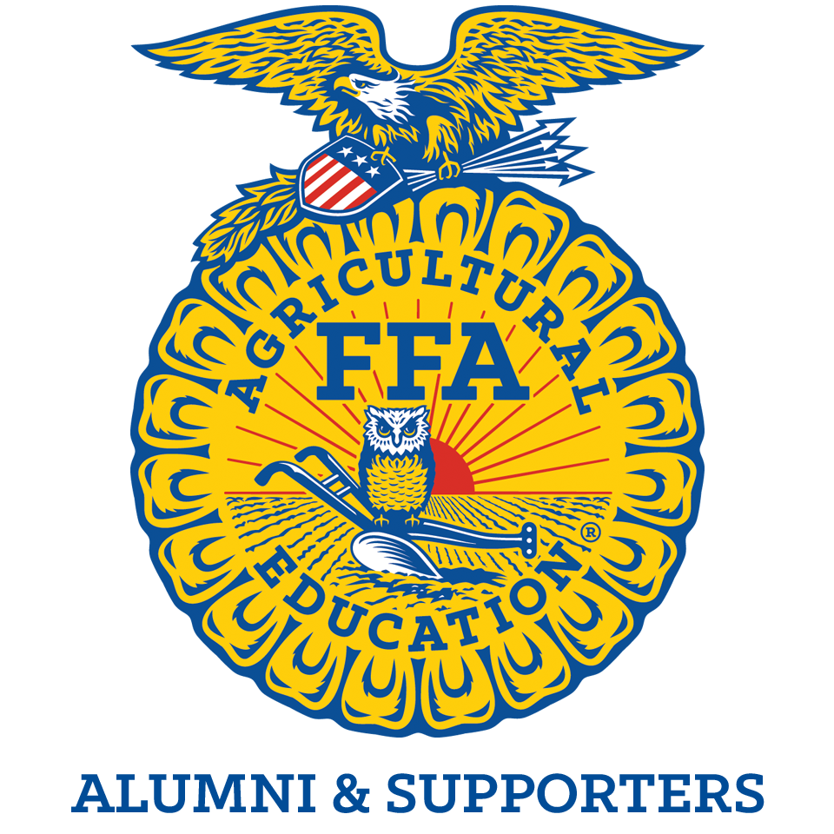
Outstanding Achievement Award Application Scorecard

Category | Points Possible | Points Awarded
Involvement:  Business Operations | 10
Involvement:  Alumni Member and Supporters Development | 10
Involvement:  Advocacy for Agricultural Education | 10
Involvement:  Agricultural Education/FFA Program Development | 10
Involvement:  Student Development | 10
TOTAL | 50

